Manufacturing Tool Quick Start Guide

Manufacturing tool, a successor of ATK, provides a series of new features to power your mass production work. The features like windows style GUI, multiple devices support, explicit status monitoring, versatile functionalities and highly flexible architecture make it a best choice to meet your critical timing, cost and customization requirements.
OK, let’s start a tour to experience the exciting features of this next generation tool now.
- Step 1
Unzip the tool package to your local directory, say: D:\mfgtools-rel\, and enter it, you will find an .exe file named MfgTool.exe. Without any installation step, you can run it directly. So, just run it. You should be able to see below user interface.
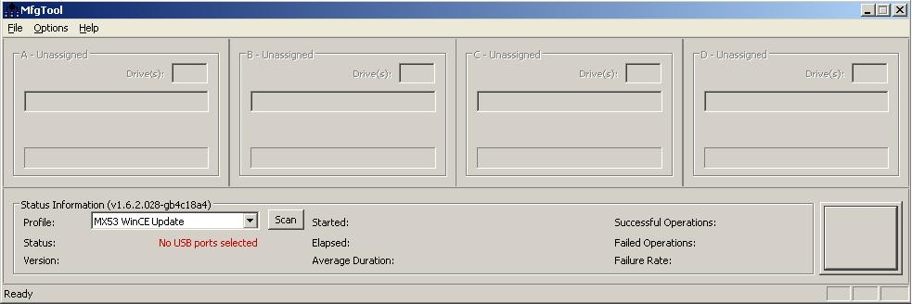
- Step 2
The user interface appears to have nothing to do since there is nothing is selected, so let’s configure something necessary.
Click Profile drop menu, you will find a number of platforms, choose the right one according to your platform.
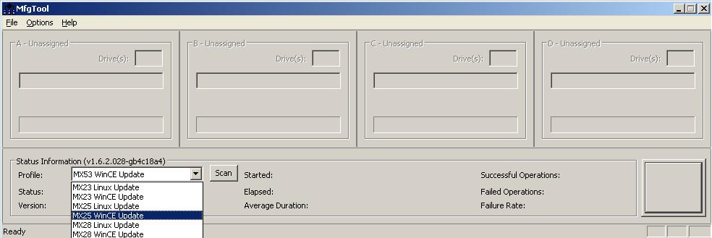
- Step 3
Now you need to connect your board to one USB port of your PC. Please make sure you have set the board to bootstrap mode before powering on the board. Please refer to platform specific document to see how to set the board to bootstrap mode.
If your device is in below device list, then you will find a HID mode device appears on your PC when you connect your board to one USB port and power on it. Please jump to Step 4.
i.MX23/28/50
If your device is in below device list, then you have to install driver for it:
i.MX25/35/51/53
You will find below popup window when you connect your board to one USB port and power on it.
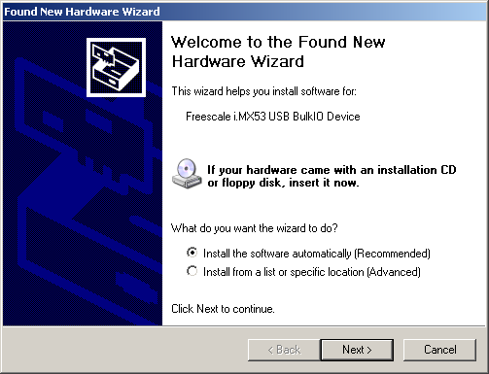
Choose “Install from a list or specific location” option and click “Next”.
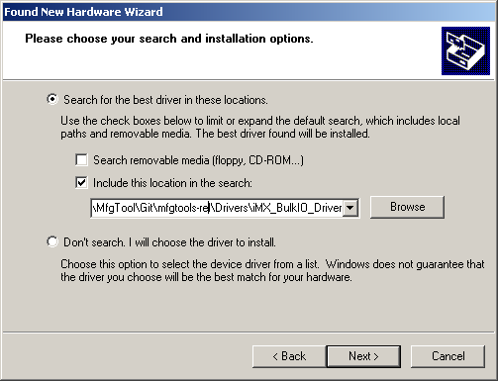
Input your driver location:
YourDiskVolume:\mfgtools-rel\Drivers\iMX_BulkIO_Driver and click “Next”.
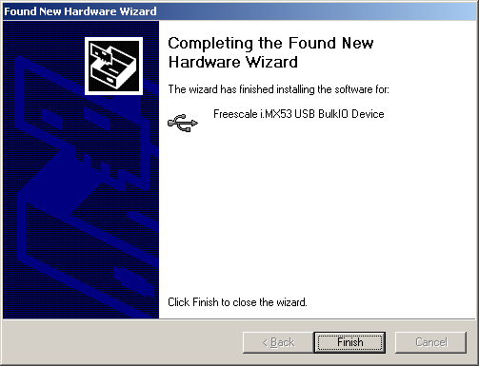
Click “Finish” to finish driver installation.
- Step 4
Click “Options” menu at upper-right corner, and further click configuration item, you can find below pop-up window. Click “USB Ports” tab, you can view all the USB port. Choose the one to which your device is connected and click “OK” to close the window.
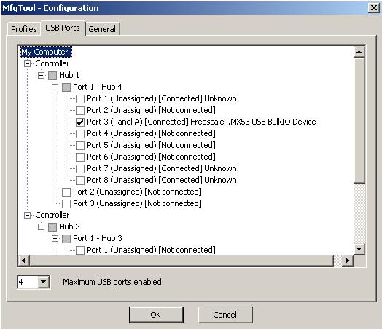

The other way is to click the “Scan” button on the main dialog to auto scan the devices connected to your PC.
- Step 5
Now you can find the tool is ready to do a demo work. Click “Start” button. If you have a terminal tool to monitor the debug serial port of your board, it is suggested to open it. You can get more information from it.
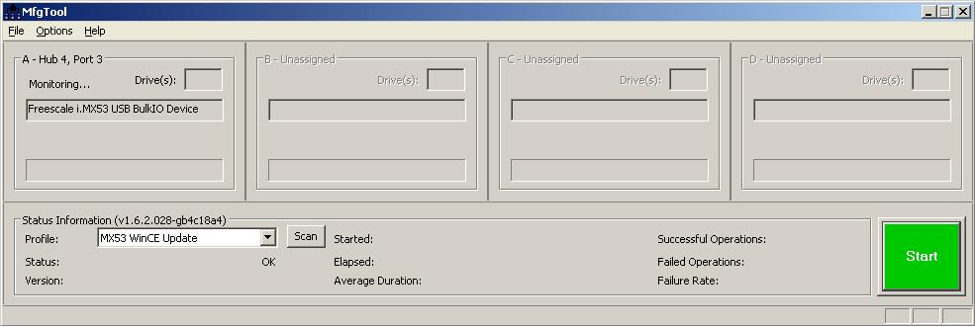
- Step 6
The process is ongoing.
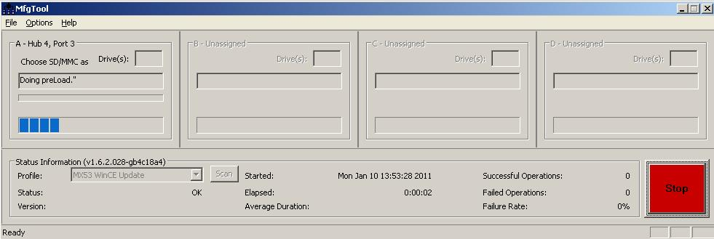
You can find some information from the terminal.
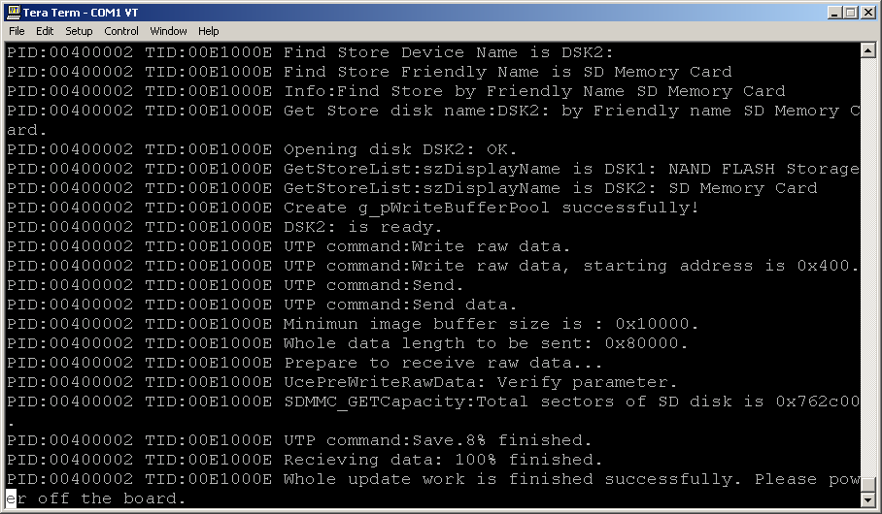
It turns to green if all the work is done. Click “Stop” to finish the demo process of the tool.
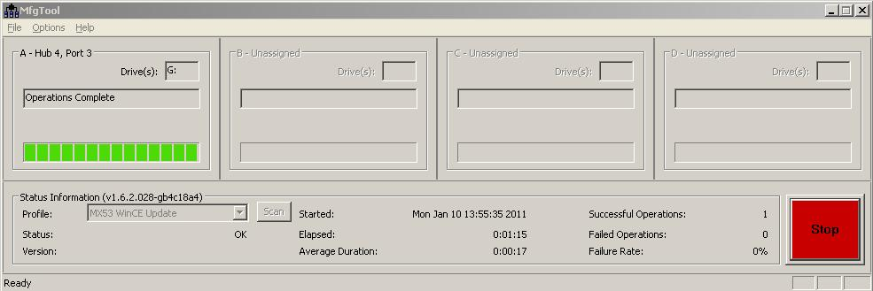

How to do your own work
If you are an operator in factory, then all the knowledge you need is enough till now. But if you are a developer, you probably have a couple of questions like how to burn my own image and default files, how to choose the dedicated storage device, etc.
The answer lies in a script: ucl.xml.
Manufacturing tool allow one uses the script to configure his/her own task list. Let’s have an overview of it. Open below file:
YourDiskVolume:\mfgtools-rel\Profiles\MX53 WinCE Update\OS Firmware\ucl.xml
You can find the script consists of one CFG section and a number of LIST sections. Never change CFG section which is used to guide the tool some platform specific configuration.
How to choose the dedicated storage device
You can see each LIST section actually indicates one storage media type. Then how to choose the one you need?
There are two ways to do this:
Method 1: Open below file:
YourDiskVolume:\mfgtools-rel\Profiles\MX53 WinCE Update\player.ini
You will find below sentence:
[OS Firmware]
UCL_INSTALL_SECTION=NAND
The value “NAND” is the one of the names of the LIST sections. Change it to your own choice.
Method 2:
You can also change the setting through the tool’s GUI. Click “Options” menu at upper-right corner, and further click configuration item, you can find below pop-up window.
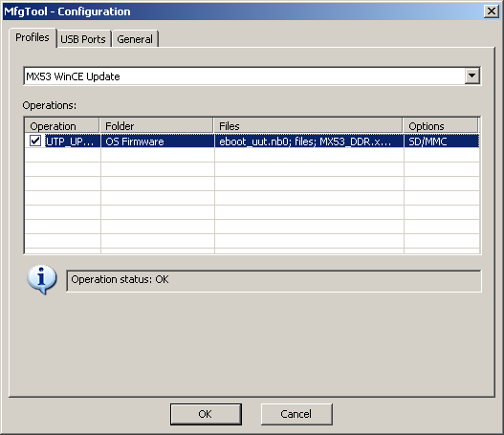
Left-click the Options item on the blue column, you can find below pop-up window.
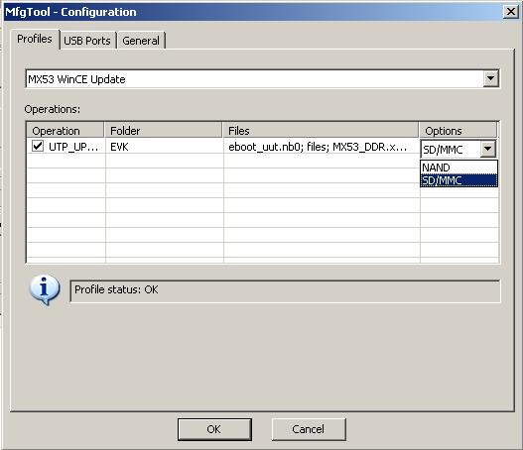
Choose your own setting and click “OK” to close the window. It’s done.
How to burn your own image
Back to ucl.xml, you can find instructions like this:
<CMD type="push" body="fwtype:EB_NB">Specify firmware type.</CMD>
<CMD type="push" body="send" file="files/eboot.nb0">Sending a firmware file.</CMD>
The value of key word “file” here figure out the relative path (base on ucl.xml path) of the image to be burned. The value of body : “fwtype:EB_NB” indicates this is an eboot. Now you should know how to specify your own image: just change the values to your own image.
If you uses another platform or other OS like Linux, the key word may be different, please refer to detailed doc to find more information.
Besides of images, you can also copy some files like demo video or audio files into the board, below instructions figure out how to specify this:
<CMD type="push" body="filename:NANDFlash\\sandy.mp3">Specify the file name and path in the board.</CMD>
<CMD type="push" body="send" file="files/sandy.mp3">Sending a file from the host.</CMD>
You can also change the values to your own one. For example:
<CMD type="push" body="filename:NANDFlash\\This is it.mp3">Specify the file name and path in the board.</CMD>
<CMD type="push" body="send" file="files/ This is it.mp3">Sending a file from the host.</CMD>

How to customize your own manufacturing tool
All above work is limited to the reference design boards provided by Freescale. If you want to utilize the tool on your own designs, you have to go further deeper.
You may notice there are files named as uce.nb0 and eboot_uut.nb0 along with ucl.xml. The two files actually are a mini OS kernel and boot loader. Each command sent to the board is executed by the OS kernel.
The OS kernel can be created using your own BSP. How to do this is a far more complicated question to explain here. Fortunately, the BSP shipped along with reference design boards by Freescale gives an example to indicate how to do this, please refer to the source code of the BSP to find more detail.

